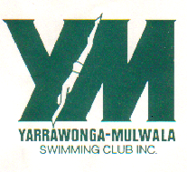

PO Box 72
YARRAWONGA 3730

Please try the sizes on and write in the size box
SIZE- Ladies
Size- Men’s
Size - Children
 | COST
Club Polo | $4500
Club Swim Cap Green | $15.00
Club Running Shorts | $45.00
Mens running shorts | $45.00
Track Jacket hoody | $85.00
Team Deck coats | $170.00
Track Pant | $70.00
Team tights Leggings | $120.00
Goggles | $30.00
Micro fibre towels | $25.00
State Navy swim Caps | $15.00
Bucket Hats | $15.00
Please could all orders be placed by the December 1st
Payment to be paid into the Yarrawonga Mulwala swimming club. BSB Account.
CMCU BSB: 803-188 Account:1000019485

